Looking to hire something bold, fun, and unforgettable?
Look no further than our Mobile Climbing Wall — the ultimate adventure experience that brings the thrill of climbing right to your event!

Perfect for parties, school fairs, corporate events, and festivals, our wall challenges climbers of all ages and skill levels. Safe, exciting, and guaranteed to draw a crowd!

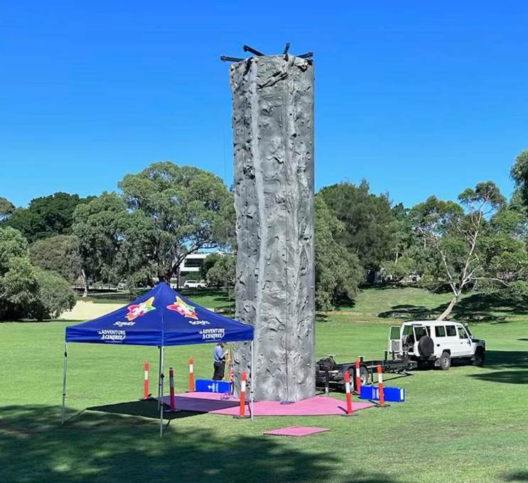
(Luita Street Reserve)

GENERAL INFORMATION about our Mobile Climbing Wall for hire:
- The length of the Mobile Climbing Wall is 25 meters
- The width is 6 meters wide, once set up
- The climbing wall is a tilt up design attached to a base trailer and towed by a 4WD
- Floor mats are provided to the base of wall for participants
- All harnesses and helmets and safety equipment is provided
- Scouts WA Adventurous Activity Facilitators are there to run the activity
- No requirement for power or other services.
- Ages from 6 years.
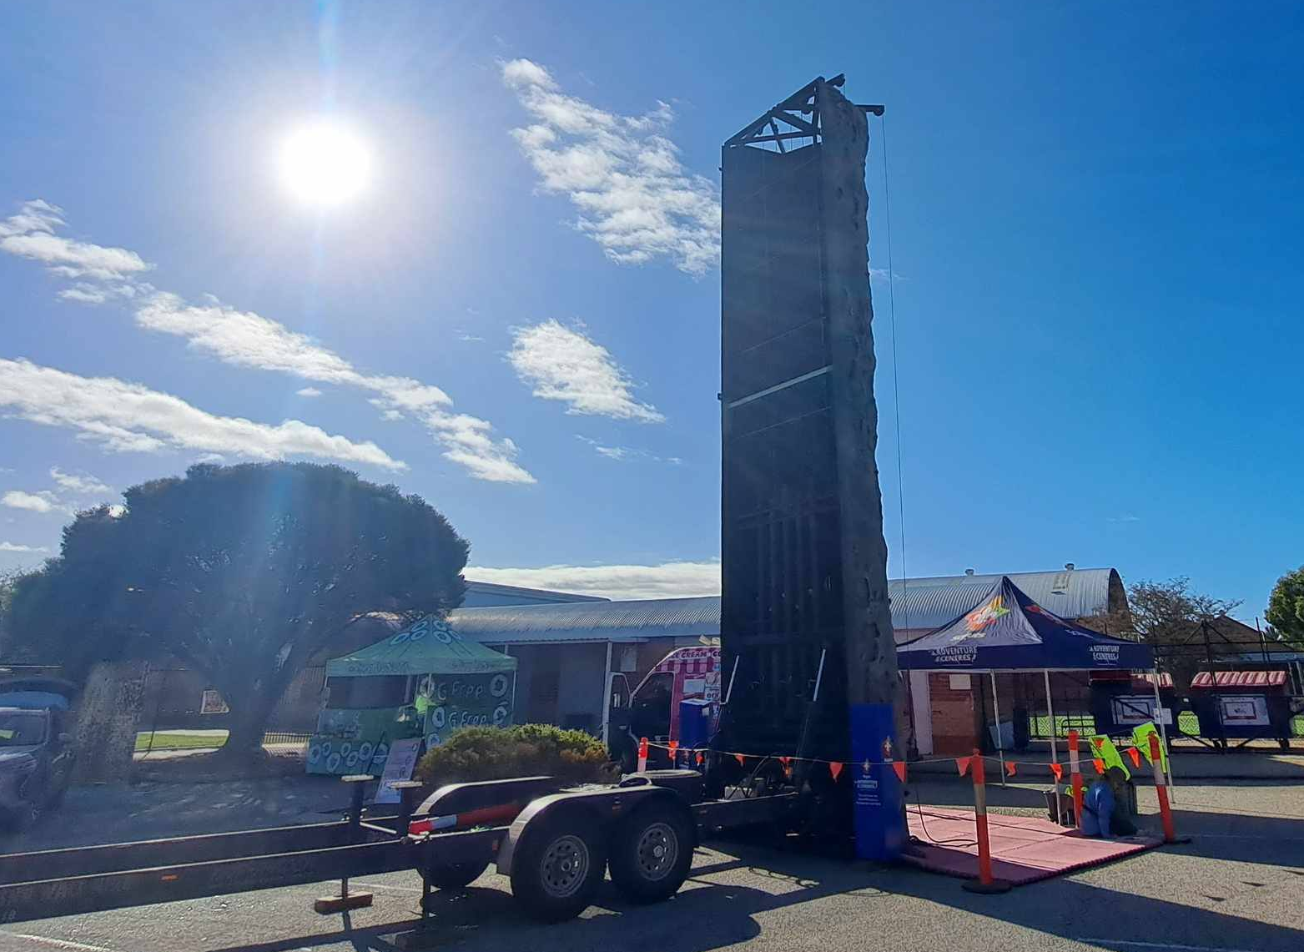
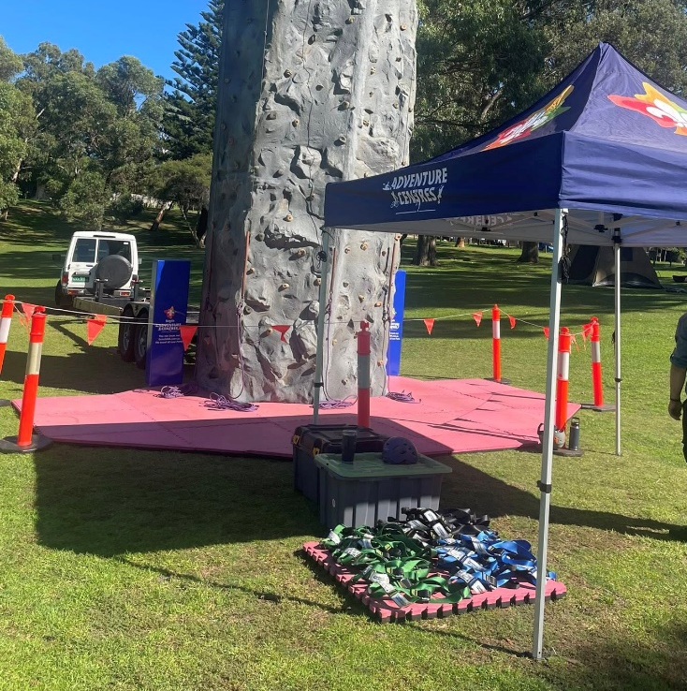

Hiring of Mobile Climbing Wall
Scouts WA Adventure Centre
163 Manjedal Road, Karrakup WA
T: (08) 9525 1210
E: sitecoordinator@scoutswa.com.au

REQUEST FOR QUOTATION:
For a no obligation quote to hire our Mobile Climbing Wall, please complete the below information and email it to sitecoordinator@scoutswa.com.au.
Name of Booking:
Contact Person Name:
Contact Details: | M: | T:
Contact Person Email:
Event Name:
Date of Event:
Location of Event:
Run Times: | From: | To:
Any specific vehicle restrictions: (i.e. access to site unavailable during certain times)
Any other comments:

