"Make your next event unforgettable with a
unique twist!"

ASK US ABOUT HIRING OUR INFLATABLE OBSTABLE COURSES!

We have 2 x Mobile Inflatable Obstacle Courses (IOC’s) available for hire
- The length of each IOC’s full course is 25 meters
- The width is 6 meters wide
- The IOC is required to pegged directly to the ground, so a grassed area is required for activity to be set up.
- Access to 240v power is preferred to run our blowers, but we do have generators if there is no power available at the hire location.
- Max 3 x blowers.

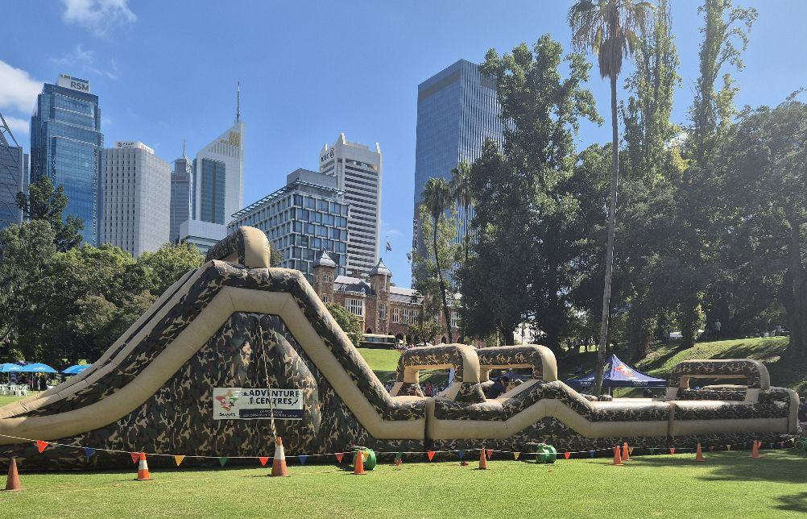
(Set up at Government House 2025)

Scouts WA Adventure Centre brings you our Inflatable Obstacle Courses

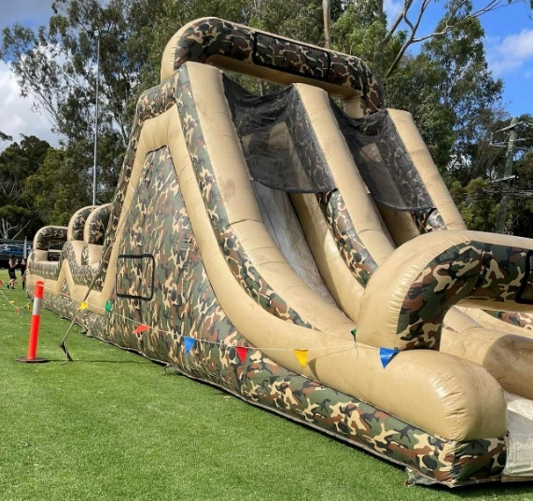
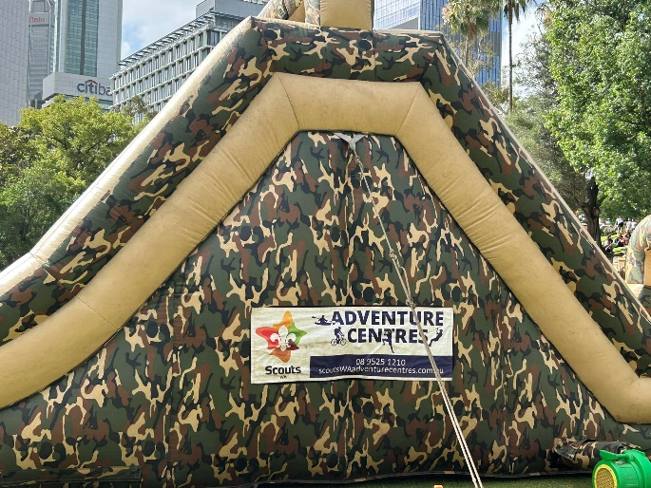

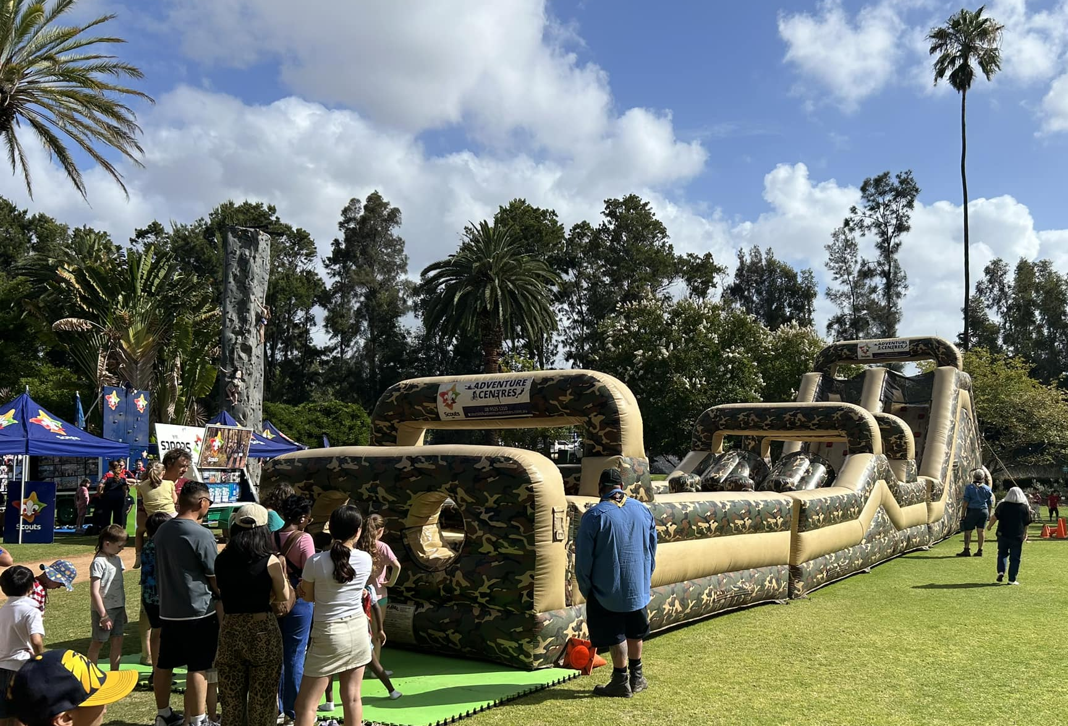
(Set up at Government House 2025)

Hiring of Mobile Inflatable Obstacle Courses
Scouts WA Adventure Centre
163 Manjedal Road, Karrakup WA
T: (08) 9525 1210
E: sitecoordinator@scoutswa.com.au

REQUEST FOR QUOTATION:
For a no obligation quote to hire one of our Mobile Inflatable Obstacle Courses, please complete the below information and email it to sitecoordinator@scoutswa.com.au.
Name of Booking:
Contact Person Name:
Contact Details: | M: | T:
Contact Person Email:
Event Name:
Date of Event:
Location of Event:
Run Times: | From: | To:
Any specific vehicle restrictions: (i.e. access to site unavailable during certain times)
Any other comments:

